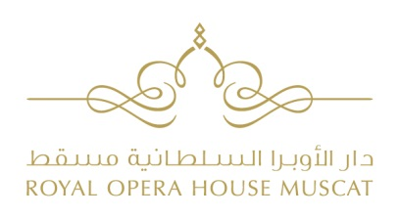

SCHOOL PERFORMANCES

REGISTRATION FORM (for schools)
School………………………………………………………………………………………………………………………………………….
Address……………………………………………………………………………………………………………………………………….. Town…………………………………………………………………………Postal Code……………….. P.O.Box…………….…
Grade/Year…………………………………………………… Number of students……………………………………………

Contact Name (Teacher/Principle):
Name............................................................... Surname ................................................................
Phone.............................................................. E-mail......................................................................

Please select a performance date below:
SHOW | DATE | TIME
Stage Presentation | November 27 | 9.00 (Arabic) | □
Stage Presentation | November 27 | 11.00 (English) | □
Percussion Presentation | April 10 | 9.00 (Arabic) | □
Percussion Presentation | April 10 | 11.00 (English) | □

Have these students attended a performance at the ROHM in the past? YES □ NO □
If yes, for which performance? ……………………………………………………….………………………………………….

Date ……………………………………… Signature……………………………………………………………..

□ Tick here if you wish to receive information by e mail from the ROHM about Education and Outreach activities.

School Performances are free-ticketed events.
Registration is kindly requested no later than 15 days prior to date of performance.
Please note that places are limited and will be allocated on first booking basis. You will receive a confirmation, upon availability.

The Registration Form must be completed legibly and in full, and sent to: education@rohmuscat.org.om

